

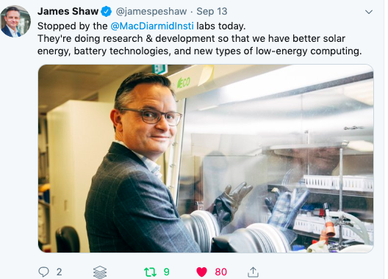

Last month, Climate Change Minister Hon James Shaw checked out sustainable technology research in our labs; [new battery technologies](https://www.macdiarmid.ac.nz/news-and-events/news/annual-reports-pages/beyond-lithium-annual-report-2018/?utm_source=Newsletter&utm_medium=Email&utm_campaign=Newsletter), luminescent solar concentrators, [printed photovoltaics](https://www.macdiarmid.ac.nz/what-we-do/out-of-the-lab/the-solar-panel-revolution/?utm_source=Newsletter&utm_medium=Email&utm_campaign=Newsletter), and [next generation computing devices](https://www.macdiarmid.ac.nz/what-we-do/out-of-the-lab/taking-the-heat-off-data/?utm_source=Newsletter&utm_medium=Email&utm_campaign=Newsletter). We also highlighted our climate change mitigation research happening at MacDiarmid Institute labs around the country, including [carbon capture research](https://www.macdiarmid.ac.nz/what-we-do/out-of-the-lab/storing-and-saving-what-is-precious/?utm_source=Newsletter&utm_medium=Email&utm_campaign=Newsletter), and materials for the hydrogen economy.

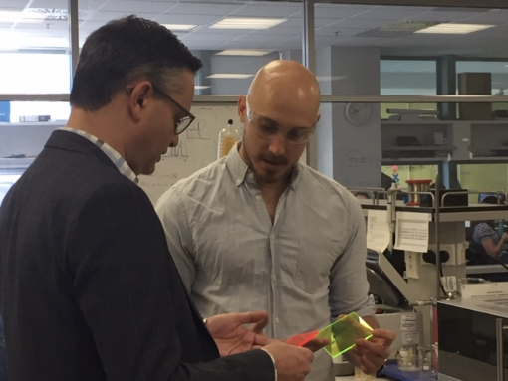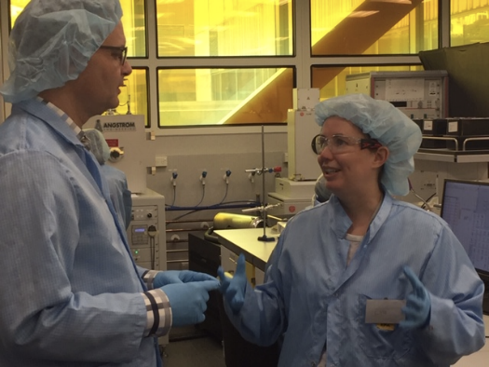

**Coming to a Rotary club near you -**MacDiarmid Institute researchers on sustainable innovation and commercialisation. Let us know if you'd like us to visit your local rotary club.

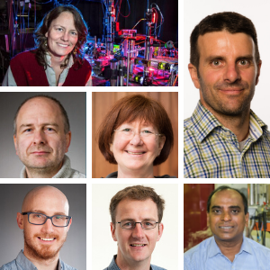[**MacDiarmid researchers successful in 2019 MBIE round**](https://www.macdiarmid.ac.nz/news-and-events/news/news-articles/mbie-endeavour-fund/?utm_source=Newsletter&utm_medium=Email&utm_campaign=Newsletter&utm_content=MBIE%20endeavour)  
Seven MacDiarmid Institute Investigators have been awarded $20.29 million funding for research through the Ministry of Business, Innovation and Employment (MBIE) Endeavour Fund. Many of the proposals are strongly motivated by searching for new sustainable innovation materials.

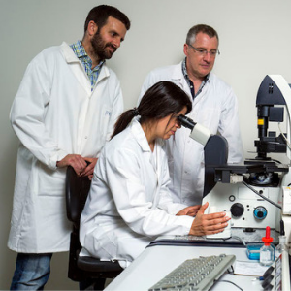[**Protecting our native trees with lab-on-a-chip research**](https://www.macdiarmid.ac.nz/news-and-events/news/news-articles/protecting-our-native-trees-with-lab-on-a-chip-research/?utm_source=Newsletter&utm_medium=Email&utm_campaign=Newsletter)  
MacDiarmid Institute Principal Investigator Dr Volker Nock has been awarded a Rutherford Discovery Fellowship to help eradicate fungi that spread disease to our native trees. To help eradicate these pathogens, he is developing lab-on-a-chip devices to understand how they locate and infect their targets.

  
[**New Trans-Tasman research will aid search for sustainable future computing**](https://www.macdiarmid.ac.nz/news-and-events/news/news-articles/new-trans-tasman-research-will-aid-search-for-sustainable-future-computing/?utm_source=Newsletter&utm_medium=Email&utm_campaign=Newsletter)  
We recently signed a joint collaboration partnership agreement with Australia's FLEET Centre to share the mission to search for future-low energy electronics via the development of novel materials and devices.

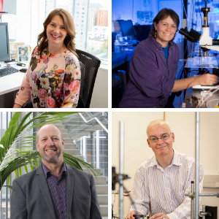

[**MacDiarmid Institute Research Honours winners**](https://www.macdiarmid.ac.nz/news-and-events/news/news-articles/macdiarmid-institute-research-honours-winners/?utm_source=Newsletter&utm_medium=Email&utm_campaign=Newsletter)  
Four MacDiarmid Institute-related researchers were awarded medals at the Royal Society Te Apārangi 2019 Research Honours ceremony. The event celebrates achievements of researchers throughout New Zealand who have strived for and realised excellence in their various disciplines.

**Jadranka Travas-Sejdic** for her contribution to the field of advanced polymers and their application in biosensors, biomedicine, and bioelectronics.

**Cather Simpson** for her pioneering research and commercialisation of innovative photonic technologies.  
  
**Keith Gordon** for his use of light to understand the molecular structure of solar cells, fish oils and plastics in the environment.  
  
**Board Member Don Cleland** for making advances in refrigeration engineering.

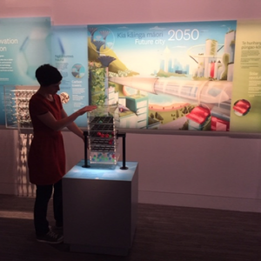[**Showcasing science for future sustainability at Te Papa**](https://www.macdiarmid.ac.nz/news-and-events/news/news-articles/showcasing-science-for-future-sustainability-at-te-papa?utm_source=Newsletter&utm_medium=Email&utm_campaign=Newsletter)  
Over 300,000 people have already seen the cool interactives in the climate change area of Te Papa's new Te Taiao | Nature exhibition. We've partnered with Te Papa to show the ways that materials science research can lesson the negative consequences of climate change.

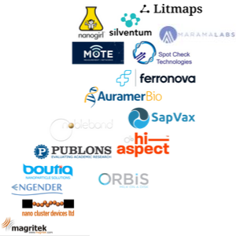[**Into the Marketplace**](https://www.macdiarmid.ac.nz/what-we-do/into-the-marketplace/macdiarmid-institute-spinout-companies/?utm_source=Newsletter&utm_medium=Email&utm_campaign=Newsletter)  
Since our inception in 2002, MacDiarmid Institute researchers have spun out 17 companies. Many of these spinouts have matured and grown to the point where they are demonstrating their benefit to society in terms of jobs created and product sold. Two of the 17 companies are making overseas sales at the scale of millions of dollars per year.

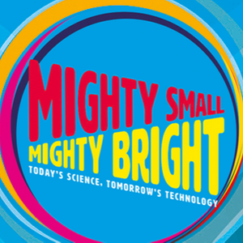[**'Mighty Small, Mighty Bright' Travelling Exhibition**](https://www.macdiarmid.ac.nz/our-partnerships/travelling-science-showcase/?utm_source=Newsletter&utm_medium=Email&utm_campaign=Newsletter)  
‘Mighty Small Mighty Bright - today’s science tomorrow’s technologies’ ran at MOTAT until 22 September, and will now travel to museums around the country, first visiting [Te Manawa Museum in Palmerston North](https://www.temanawa.co.nz/event/mighty-small-mighty-bright/) on 23 November.

Dr Michelle Dickinson dropped in to check out the exhibition at MOTAT and run a nanoscience talk for about 50 Auckland school kids.

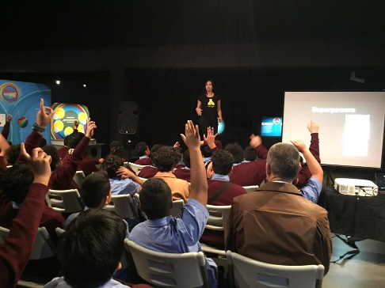 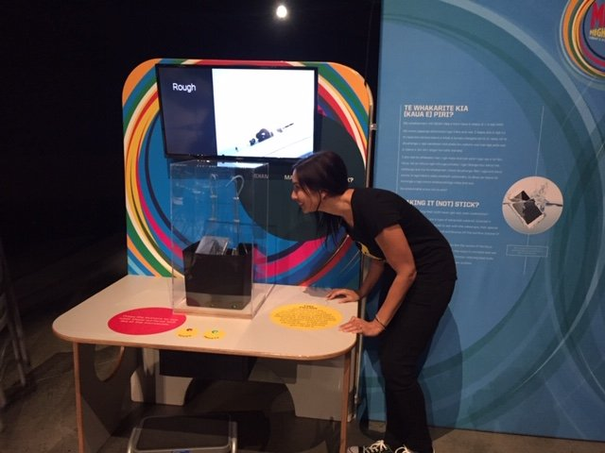



[Element of the Week - Gallium (Ga)](https://www.macdiarmid.ac.nz/news-and-events/podcasts/element-of-the-week-gallium/?utm_source=Newsletter&utm_medium=Email&utm_campaign=Newsletter&utm_content=Gallium) - **RadioNZ Nights**  
Each week Bryan Crump from RadioNZ talks 'Element of the Week' with a different researcher. Listen to Associate Professor Nicola Gaston, Co-Director of the MacDiarmid Institute, talk about Gallium and why this metal sums up so much about the periodic table.

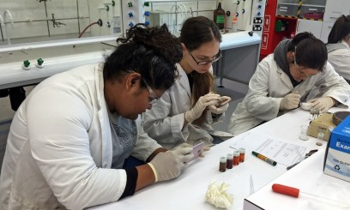[The camp where young Māori and Pasifika expore the wonders of science](https://thespinoff.co.nz/science/26-07-2019/the-camp-where-young-maori-and-pasifika-explore-the-wonders-of-science/)**- The Spinoff**  
Our annual DiscoveryCamp gives Māori and Pacific high school students the chance to experience science at a tertiary level. Alice Webb-Liddall finds out why it’s important to get these young people interested.

[The cure for climate change could be in our own backyard](https://thespinoff.co.nz/science/04-06-2019/the-cure-for-climate-change-could-be-in-our-own-backyard/)**- The Spinoff**  
Climate treaties, sustainability goals and energy commitments are proliferating around the world. The answers to these targets must involve new materials and research in this area is happening in New Zealand, writes our Deputy Director Dr Geoff Willmott.

  
[You're eating plastic pollution - around the weight of a credit card's worth each week](https://www.nzherald.co.nz/nz/news/article.cfm?c_id=1&objectid=12260911)**- The NZ Herald**  
All of us are eating a lot of plastic without knowing it – maybe as much as a credit card amount each week, but now authorities have allayed some of the fears around what that means for our health.

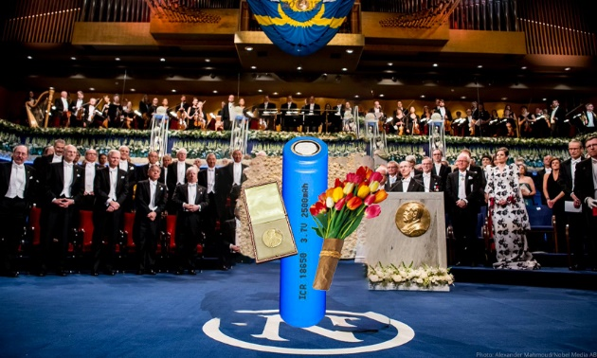[After decades of service, the lithium-ion battery has won a Nobel Prize](https://thespinoff.co.nz/science/27-10-2019/after-decades-of-service-the-lithium-ion-battery-has-won-a-nobel-prize/) - **The Spinoff**  
The lithium-ion battery has won this year’s Chemistry Nobel Prize. Our Co-Director Justin Hodgkiss celebrates the slow and steady speed of technological developments.